# Team “Monster”

## For OOP Teamwork assignment, Telerik Academy, Feb.2014

Team “Monster” consists of:

* Svilen Bonev / Свилен Бонев
* Yassen Mihailov / Ясен Михайлов
* Dobromir Brezoev / Добромир Брезоев
* Yordan Poydovski / Йордан Пойдовски
* Angel Dimitrov / Ангел Димитров
* Georgi Yakimov / Георги Якимов

And we present our project “PacMan”

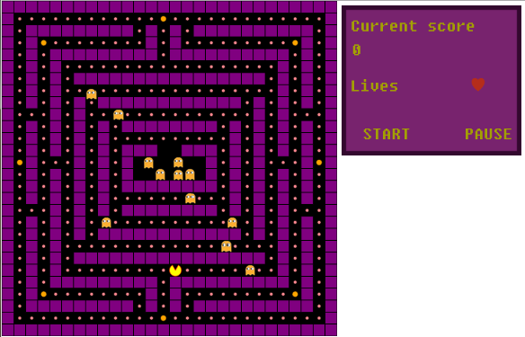

PacMan is a RPG game. Pac-Man is considered one of the classics of the electronic games at all. Our implementations is quite close to the common vision of the game.

The goal of the game is collecting the food spots and avoiding the ghosts especially when we don’t have the special pill which gives us the strength to “eat” the ghost.

The game was created using JavaScript and some of the popular libraries like RaphaelJS and KineticJS. The game structure follows OOP principles in Javascript and some high quality writing techniques.

GitHub repository: [GITHUB_REPOSITORY_HYPERLINK https://github.com/TeamMonsterJS/TeamMonsterGame](GITHUB_REPOSITORY_HYPERLINK%20https://github.com/TeamMonsterJS/TeamMonsterGame)